**DROWSINESS DRIVER ANTISLEEP ALARM**

## A PROJECT REPORT

***Submitted by***

**C.SATHYABAMA(20103076)**

**N.SOBIYA (20103085)**

**V.SUBHASHINI(20103091)**

**R.SWETHA(20103095)**

***In partial fulfillment for the award of the degree of***

**BACHELOR OF ENGINEERING IN**

**ELECTRONICS AND COMMUNICATION ENGINEERING**

## VIVEKANANDHA COLLEGE OF ENGINEERING FOR WOMEN [Autonomous]

*Approved by AICTE, New Delhi*

*Affiliated to Anna University, Chennai-25, An ISO 9001-2008*

*Certified Institution*

Elayampalayam, Tiruchengode, Namakkal Dt. – 637205.

## VIVEKANANDHA COLLEGE OF ENGINEERING FOR WOMEN [Autonomous]

*Approved by AICTE, New Delhi*

*Affiliated to Anna University, Chennai-25, An ISO 9001-2008 Certified Institution*

Elayampalayam, Tiruchengode, Namakkal Dt. – 637205.

### COLLEGE VISION

To impart value based education in Engineering and Technology to empower young women to meet the societal exigency with a global outlook.

### COLLEGE MISSION

* To provide holistic education through innovative teaching-learning practices 
* To instill self confidence among rural students by supplementing with co- curricular and extra-curricular activities 
* To inculcate the spirit of innovation through training, research and development 
* To provide industrial exposure to meet the global challenges 
* To create an environment for continual progress through lifelong learning 

### DEPARTMENT VISION

To Produce Innovative, Creative, Ethical and Socially responsible Electronics and

Communication women engineers to meet the global challenges

### DEPARTMENT MISSION

Department of ECE is committed to

* To create a unique learning environment in Electronics and Communication

Engineering to mould a strong engineer with professional ethics 

* To provide practical exposure to compete in the global market 
* Fostering culture of innovation, research and lifelong learning 

## VIVEKANANDHA COLLEGE OF ENGINEERING FOR WOMEN [Autonomous]

*Approved by AICTE, New Delhi*

*Affiliated to Anna University, Chennai-25, An ISO 9001-2008 Certified Institution*

Elayampalayam, Tiruchengode, Namakkal Dt. – 637205.

**B. E. - ELECTRONICS AND COMMUNICATION ENGINEERING**

**Regulation 2019**

## CHOICE BASED CREDIT SYSTEM

**PROGRAMME EDUCATIONAL OBJECTIVES (PEOs):**

Graduates of Electronics and Communication Engineering will

**PEO 1** To offer strong theoretical and practical knowledge with managerial skills

and entrepreneurial competencies.

**PEO 2** To impart analytic and questioning skills to broaden innovative ideas for Research and Development based on Industry requirements.

**PEO 3** To achieve a high level technical expertise in Electronics and Communication Engineering and inculcate professional ethics and social concern

**PROGRAMME OUTCOMES (POs):**

**PO 1.** Apply the knowledge of mathematics, science, engineering

fundamentals, and an engineering specialization to the solution of complex engineering problems.

**PO 2.** Identify, formulate, review research literature, and analyze complex engineering problems reaching substantiated conclusions using first principles of mathematics, natural sciences, and engineering sciences.

**PO 3.** Design solutions for complex engineering problems and design system

components or processes that meet the specified needs withappropriate consideration for the public health and safety, and the cultural, societal, and environmental considerations.

**PO 4.** Use research-based knowledge and research methods including design

of experiments, analysis and interpretation of data, and synthesis of the information to provide valid conclusions.

**PO 5.** Create, select, and apply appropriate techniques, resources, and

modern engineering and IT tools including prediction and modeling to complex engineering activities with an understanding of the limitations.

**PO 6.** Apply reasoning informed by the contextual knowledge to assess

societal, health, safety, legal and cultural issues and the consequent responsibilities relevant to the professional engineering practice.

**PO 7.** Understand the impact of the professional engineering solutions in

societal and environmental contexts, and demonstrate the knowledge of, and need for sustainable development.

**PO 8.** Apply ethical principles and commit to professional ethics and

responsibilities and norms of the engineering practice.

**PO 9.** Function effectively as an individual, and as a member or leader in

diverse teams, and in multidisciplinary settings.

**PO 10.** Communicate effectively on complex engineering activities with the

engineering community and with society at large, such as, being able to comprehend and write effective reports and design documentation, make effective presentations, and give and receive clear instructions.

**PO11.** Demonstrate knowledge and understanding of the engineering and

management principles and apply these to one's own work, as a member and leader in a team, to manage projects and in multidisciplinary environments.

**PO 12.** Recognize the need for, and have the preparation and ability to engage in

independent and life-long learning in the broadest context of technological change.

**PROGRAM SPECIFIC OUTCOMES (PSOs):**

**PSO1:** Comprehend the basic concepts of electronics and communication and

apply in the day to day life to design and execute complete engineering systems.

|  |  |
| --- | --- |
| **PSO2:** | Design, verify and validate electronic functional elements for numerous applications including signal processing, communications, computer networks and VLSI. |
| **PSO3:** | Demonstrate the intellectual level with peer engineers and others to work |

together to arrive at a cost-effective, appropriate solution for various problems.

**VIVEKANANDHA COLLEGE OF ENGINEERINGFOR WOMEN(AUTONOMOUS)**

## BONAFIDE CERTIFICATE

Certified that this project report **“DROWSINESS DRIVER ANTISLEEP ALARM”** is the bonafide workof **“C.SATHYABAMA(20103076) N.SOBIYA (20103085) V.SUBHASHINI(20103091) R.SWETHA(20103095)”** who carried out the projectwork under my supervision.

|  |  |
| --- | --- |
| SIGNATURE OF THE HOD  **Dr.P.T.KALAIVANI M.E.,Ph.D.,PDF**  **HOD/ECE**  Vivekanandha College of Engineering for  Women (Autonomous) Tiruchengode. | SIGNATURE OF THE GUIDE:  **Ms.R.INDHUMATHI M.E**  **AP/ECE**  Vivekanandha College of Engineeringfor  Women (Autonomous) |

Tiruchengode.

Submitted to the Viva voce Examination held on

**INTERNAL EXAMINER EXTERNAL EXAMINER**

# 

# ACKNOWLEDGEMENT

We are immense pleasure and privilege to thank our honorable Chairman &

Secretary, Vidya Ratna **Prof. Dr. M.KARUNANITHI B.Pharm., MS., Ph.D., D.litt.,** Vivekanandha Educational Institutions, who is our inspiration.

We would like to express our deep gratitude and thanks to our honorable Executive Director, **Prof. S. KUPPUSWAMI B.E, M.Sc. (Engg), Dr. Ing (France)** who always motivate us toward our academic development.

We wish to express our profound thanks to our beloved and honorable Principal, **Dr.KCK.VIJAYAKUMAR M.E.,Ph.D.,FIE.,**and for all the facilities and support provided during the period of Project work.

We are extremely grateful and deeply indebted to our **Head of the Department**

**Dr.PT.KALAIVANI M.E,Ph.D.,PDF.,**Department of Electronics and Communication Engineering for her encouragement and support for completing the Project successfully.

We wish to thank our Project coordinator **Ms.R.INDHUMATHI M.E., AssistantProfessor/ECE** for his kind support and guidance in completion of our Project report writing successfully.

We express our sincere thanks and regards to our supervisor, **Ms.R.INDHUMATHI M.E., AssistantProfessor/ECE** for her encouragement and valuable suggestions throughout the Project.

We convey our immense gratitude to our department teaching and non-teaching staff members for their support and encouragement throughout our project work. We thank our parents, friends and everyone else for all that they have done behind us to complete our project work successfully.

# 

**ABSTRACT:**

Drowsy driving is a serious safety concern that can lead to accidents and fatalities on the road. When a driver is tired, their reaction time slows down their ability to concentrate decreases, and they may even fall asleep behind the wheel. A drowsy driver alert device can help prevent these accidents by detecting when the driver is showing signs of fatigue and alerting them to take a break or pull over to rest. These devices use eye tracking or steering wheel sensors to monitor the driver’s behaviour and alert them when necessary. By using a drowsy driver alert device, drivers can be more aware of their own fatigue and take action to prevent accident before they occur. It can also help reduce the risk of accident caused by drowsy driving which can have a significant impact on public safety and reduce the economic costs associated with accidents. Over all a drowsy driver alert device can improve road safety and save lives.

The project on drowsy driver alert system aims to develop a safety device that can detect the signs of driverfatigue and alert the driver to prevent accidents. The system will use various sensor such as eye tracking, steering angle and acceleration to monitor the driver’s behaviour and determine if they are becoming drowsy. Once signs of fatigue are detected, the device will emit an audible or visual alert to the driver, alerting them to take a break or change their driving behaviour. The purpose of this project is to improve road safety by reducing the number of accidents caused by driver fatigue.

**CHAPTER TABLE OF CONTENTS PAGE NO.**

**NO PARTICULARS**

**ACKNOWLEDGEMENT** **vii**

**ABSTRACT** **viii**

**LIST OF TABLES** **xi**

**LIST OF FIGURES** **xii**

**LIST OF ABBREVATIONS xiii**

1. **INTRODUCTION 2**
2. **LITERATURE SURVEY 3**

2.1. LETERATURE REVIEW 3

2.2.1.LITERATURE SUMMARY 5

2.2.EXISTING SYSTEM 6

2.2.1.DRAWBACKS OF EXISTING SYSTEM 6

1. **PROPOSED SYSTEM 8**

3.1.OVERVIEW 8

3.2.BLOCK DIAGRAM 9

3.2.1BLOCK DIAGRAM EXPLANATION 9

3.3. CIRCUIT DIAGRAM 12

3.3.1.CIRCUIT DIAGRAM EXPLANATION 13

3.4.ADVANTAGES OF PROPOSED SYSTEM 13

1. **MODULE DESCRIPTION 15**

4.1.HARDWARES AND DESCRITION

4.1.1.ARDINO UNO 15

4.1.2.EYE BLINK SENSOR 18

4.1.3. BUZZER 20

4.1.5.IOT MODULE 22

4.1.6.MASSIVE IOT MODULES 23

4.1.7.SMART MODULES 23

4.1.8.AUTOMOTIVE-GRADE MODULES 23

4.2 SOFTWARE DESCRIPTION 24

4.2.1.ARDUINO UNO 24

1. **RESULT AND DISCUSSION 27**

5.1.IMPLEMENTATION RESULT 27

5.2.OUTPUT SCREEN SHOTS 30

1. **CONCLUSION AND FUTURE ENHANCEMENT 31**

6.1.CONCLUSION 31

6.2.FUTURE ENHANCEMENT 32

6.3.APPLICATIONS 34

1. **REFERENCES 35**

**APPENDIX 37**

# 

# LIST OF TABLES

## TABLE TABLE NAME PAGE NO

4.1.1 TECHNICAL SPECIFICATION OF ARDUINO 15

# LIST OF FIGURES

**FIGURE NO FIGURE NAME PAGE NO**

**3.1** Block Diagram **9**

**3.2** Circuit Diagram **12**

**4.1** Arduino UNO **16**

**4.**2 Eyeblink sensor **18**

4.3 Buzzer **20**

**4.4** IoT Module **22**

**4.5** Arduino UNO Software **25**

**5.1** Implementation of output **28**

**5.2** Project Result **30**

## LIST OF ABBREVIATION

**IOT** Internet of things

**EEG** Electroencephalography

**EMG**  Electromyography

**EOG** Electrooculography

**SVM** Support vector machine

**VCC**  Power supply

**GND** Ground

**TTL** Transistor-transistor Logic

**USB** Universal Serial Bus

## CHAPTER 1

### INTRODUCTION

Driving while drowsy is a major safety concern on the roads, leading to a significant number of accidents each year. To address this problem, a drowsy driver alert system can be a life saving technology. This system uses sensors and algorithms to monitor driver’s behaviour, including steering patterns, eye moments, and other indicators of fatigue. When the system detects that the driver is becoming drowsy, it alerts the driver, potentially preventing an accident. The aim of this project is to develop a drowsy driver alert system that can effectively detect driver fatigue and alert the driver in real time. In addition to its potential to save lives, this technology can also have significant economic benefits, reducing the costs associated with accidents, injuries, and property damage.

This project will involve designing and implementing the hardware and software components of the system, as well as testing and refining the system’s accuracy and reliability. The end result will be a comprehensive drowsy driver alert system that can be integrated into vehicles to help improve road safety and prevent accidents caused by driver fatigue.

## CHAPTER 2

**LITERATURE SURVEY**

**LITERATURE REVIEW**

**1.A comprehensive study on Drowsy Driver Detection Systems**

A.E. Ceitin describes the importance of detecting drowsiness in drivers and the consequences of not doing so. The physiological methods include EEG, EOG, EMG. It monitors head and eye movements, steering behaviour and lane deviation. It suggests that combination of physiological, behavioural, and vehicle based methods could provide a more robust and accurate approach to detecting drowsiness in drivers.

**3.Smart Car:Drowsy Driver Detection and Alert System – by A.R. Agarwal , S.J. Gajjar, and D.M Thakore:**

Agarwal describes the uses of combination of sensors, including a camera, to monitor the driver's face and detect signs of drowsiness, such as yawning or eye closure. The system also includes an alert mechanism to notify the driver if signs of drowsiness are detected. The system's effectiveness may be limited in scenarios where the driver's face is not visible or partially obscured, such as when wearing sunglasses or a hat. Additionally, the system's reliance on camera-based sensors may limit its applicability to scenarios where camera-based sensors are not available or reliable, such as in low light conditions or adverse weather conditions. Finally, the system's effectiveness may be impacted by individual differences in drowsiness patterns or driving habits, which may require personalized calibration or adaptation.

**2.Real time drowsiness detection system for drivers - by N.Mahmud, M.N.H. Siddiquee, and M.I.Kabir:**

The author describes this project , which uses a camera to capture images of the driver’s face and applies computer vision techniques to detect signs of drowsiness , such as eye closure and yawning. There are few limitations that is the system’s accuracy may be impacted by factors such as the driver’s baseline physiological data driving style and environmental conditions .

**3.Smart Car :Drowsy Driver Detection and Alert System – by A.R. Agarwal , S.J. Gajjar, and D.M Thakore:**

Agarwal describes the uses of combination of sensors, including a camera, to monitor the driver's face and detect signs of drowsiness, such as yawning or eye closure. The system also includes an alert mechanism to notify the driver if signs of drowsiness are detected. The system's effectiveness may be limited in scenarios where the driver's face is not visible or partially obscured, such as when wearing sunglasses or a hat. Additionally, the system's reliance on camera-based sensors may limit its applicability to scenarios where camera-based sensors are not available or reliable, such as in low light conditions or adverse weather conditions. Finally, the system's effectiveness may be impacted by individual differences in drowsiness patterns or driving habits, which may require personalized calibration or adaptation.

**4. Drowsy Driver Detection System Using EEG and SVM - by S. S. Shah and V. K. Patil:**

Shah proposes a drowsy driver detection system based on EEG signals and SVM algorithm. The proposed system uses an EEG headset to record brainwave signals from the driver and processes the signals using an SVM algorithm to detect signs of drowsiness, such as increased alpha waves or decreased beta waves. The system's effectiveness may be limited by individual differences in EEG signals or drowsiness patterns, which may require personalized calibration or adaptation. Additionally, the EEG headset may be uncomfortable or cumbersome for some drivers to wear, which may limit the system's usability in real-world scenarios.

**5. Real-time Drowsy Driver Detection System based on CNN and LSTM Neural Network - by Y. Hu and Y.Zhang:**

It extracts facial and eye features from video footage to detect signs of drowsiness using the CNN and LSTM neural networks. The authors also conducted experiments to evaluate the performance of the system and found that it achieved a high level of accuracy in detecting drowsiness. The system's accuracy may be impacted by factors such as lighting conditions, camera placement, and facial expressions, which may affect the accuracy of the facial and eye feature extraction.

## 2.2 EXISTING SYSTEM

In existing method, eye blink sensor is used which detects the driver's eye blinks and sends a signal to the Arduino Uno microcontroller. The Arduino then processes the signal and the output of the Arduino uno activates a buzzer connected to its positive and negative wires, which alerts the driver of drowsiness and prompts the driver to take a break or rest.

### 2.2.1 DRAWBACKS OF EXISTING SYSTEM

**Limited accuracy**: The accuracy of the eye blink sensor may vary depending on the lighting conditions, the driver's facial features, and the calibration of the sensor. This can result in false negatives, where the system fails to detect drowsiness, or false positives, where the system detects drowsiness when the driver is actually alert.

**Limited functionality**: The drowsy driver alert system with an eye blink sensor, an Arduino Uno, and a buzzer can only detect drowsiness based on the driver's eye movements. It cannot detect other signs of drowsiness, such as yawning or slouching, which may also indicate that the driver is drowsy.

## CHAPTER 3

**PROPOSED SYSTEM**

### 3.1 OVERVIEW

In the earlier they had developed this Drowsy alert system.It works with a single blink of the human eye and will gives the alarm . This it makes a disturbance of repetition of alarm for a single blink to the driver and sometimes it may even cause accident. In the modern , we had developed this project with two monitoring steps for detecting the eye blink movement. If the monitoring is over , the collected data will be transmitted to a microcontroller digitizes the analog data . If the warning feedback system is triggered the buzzer will give sound after 5secs once when the person closed their eyes .

### 3.2 BLOCK DIAGRAM

BUZZER

BATTERY

BREAD BOARD

ARDUINO UNO

EYE BLINK SENSOR

**Fig 3.1 Block diagram**

**3.2.1 BLOCK DIAGRAM EXPLANATION**

**EYE BLINK SENSOR :**

An eye blink sensor is a type of sensor that detects the opening and closing of the eyelids by monitoring the electrical activity of the muscles around the eyes. The sensor can be attached to a pair of glasses or a headband worn by the driver, and it works by measuring changes in the electrical signals that occur when the eyelids move.

In a drowsy driver alert system, the eye blink sensor is used to detect if the driver is closing their eyes for an extended period, indicating drowsiness or fatigue. The sensor sends signals to the microcontroller (such as an Arduino Uno) which processes the signals and decides whether the driver is alert or drowsy. If the driver is detected as drowsy, the system can activate a buzzer or other alerting mechanism to prompt the driver to take a break or rest.

**BUZZER:**

A buzzer is an electronic device that produces a continuous or intermittent sound when activated. In a drowsiness driver alert system, a buzzer is used to alert the driver when the system detects signs of drowsiness or fatigue. When the system determines that the driver is becoming drowsy, it activates the buzzer to prompt the driver to take a break or rest.

The buzzer can be connected to the microcontroller (such as an Arduino Uno) through a digital output pin, and can be programmed to produce different types of sounds or patterns depending on the level of drowsiness detected. For example, the buzzer may produce a low-frequency tone or series of beeps to indicate that the driver is starting to become drowsy, and a high-frequency tone or continuous alarm to indicate a higher level of drowsiness.

**ARDUINO UNO:**

Arduino Uno is a microcontroller board based on the ATmega328P microcontroller. In a drowsiness driver alert system, Arduino Uno is used as the main control unit to read data from the sensors, analyze the data, and control the alert mechanism (e.g. the buzzer).

The Arduino Uno board has a number of digital and analog input/output pins that can be used to interface with various components of the drowsiness driver alert system. For example, the eye blink sensor can be connected to one of the analog input pins, while the buzzer can be connected to one of the digital output pins.

### 

### 

**3.2 CIRCUIT DIAGRAM**

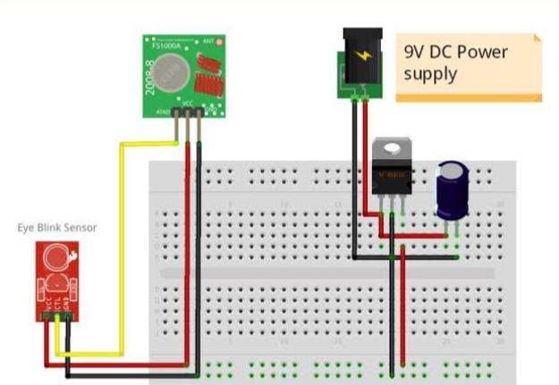

**Fig 3.2 Circuit Diagram**

#### 3.3.1. CIRCUIT DIAGRAM EXPLANATION

Connect the positive (red) wire of the buzzer to a digital output pin on the Arduino, in this case pin 3.

Connect the negative (black) wire of the buzzer to a ground pin on the Arduino.

Place the buzzer on the breadboard with the positive wire in one row and the negative wire in another row.

Connect a jumper wire from the same row as the positive wire of the buzzer to the digital output pin 3 on the Arduino.

Connect another jumper wire from the same row as the negative wire of the buzzer to any ground pin on the Arduino.

With these connections, the Arduino can send a signal to turn the buzzer on and off when a blink is detected.

.

### 3.4. ADVANTAGES OF PROPOSED SYSTEM

A drowsiness driver alert system can help prevent accidents caused by drivers falling asleep at the wheel.

The system can detect signs of drowsiness in a driver and provide an early warning before the driver becomes fully asleep.

The system can continuously monitor a driver's condition in real-time, making it more effective than human intervention, which can be slow or delayed.

The system can be customized to the specific needs of a driver, such as adjusting the sensitivity of the sensors or the frequency of alerts.

With the use of low-cost sensors and microcontrollers, a drowsiness driver alert system can be implemented at a relatively low cost compared to other safety systems

## CHAPTER 4

**MODULE DESCRIPTION**

### 4.1 HARDWARE DESCRIPTION

#### 4.1.1 ARDUINO UNO

The Arduino Uno is a microcontroller board based on the

ATmega328. Ithas 14 digital input/output pins (of which 6 can be used as PWM outputs), 6 analog inputs, a 16 MHz crystal oscillator, a USB connection, a power jack, an ICSP header, and a reset button. It contains everything needed to support themicrocontroller; simply connect it to a computer with a USB cable or power it witha AC-to-DC adapter or battery to get started. The Uno differs from all preceding boards in that it does not use the FTDI USB-to-serial driver chip. Instead, it featuresthe Atmega8U2 programmed as a USB-to-serial converter.

### TECHNICAL SPECIFICATION

|  |  |
| --- | --- |
| Microcontroller | ATmega328 |
| Operating Voltage | 5V |
| Input Voltage (limits) | 6-20V |
| Digital I/O Pins | 14 (of which 6 provide PWM output) |
| Analog Input Pins | 6 |
| DC Current per I/O Pin | 40mA |
| DC Current for 3.3V Pin | 50mA |

### Table 4.1.1 Technical specification of Arduino

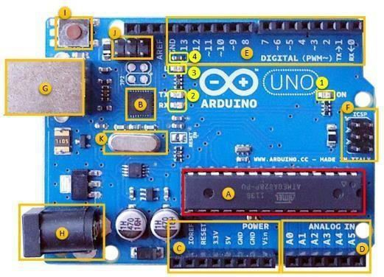

#### Fig 4.1 Arduino UNO

The Arduino Uno can be powered via the USB connection or with an external power supply. The power source is selected automatically.

External (non-USB) power can come either from an AC-to-DC adapter (wall-wart) or battery. The adapter can be connected by plugging a 2.1mm center- positive plug into the board's power jack. Leads from a battery can be inserted in theGnd and Vin pin headers of the POWER connector. The board can operate on an external supply of 6 to 20 volts. If supplied with less than 7V, however, the 5V pin may supply less than five volts.

If using more than 12V, the voltage regulator may overheat and damage the board. The recommended range is 7 to 12 volt

The Atmega328 has 32 KB of flash memory for storing code (of which 0,5KB is used for the bootloader); It has also 2 KB of SRAM and 1 KB of EEPROM (which can be read and written with the [EEPROM library)](http://www.arduino.cc/en/Reference/EEPROM).

Each of the 14 digital pins on the Uno can be used as an input or output,using [pinMode(),](http://arduino.cc/en/Reference/PinMode) [digitalWrite(),](http://arduino.cc/en/Reference/DigitalWrite) and [digitalRead()](http://arduino.cc/en/Reference/DigitalRead) functions.

They operate at 5 volts.

Each pin can provide or receive a maximum of 40 mA and has an internal pull-up resistor (disconnected by default) of 20-50 kOhms. In addition, some pins have specialized functions:

**PWM: 3, 5, 6, 9, 10, and 11.** Provide 8-bit PWM output with the [analogWrite()f](http://arduino.cc/en/Reference/AnalogWrite)unction.

**SPI: 10 (SS), 11 (MOSI), 12 (MISO), 13 (SCK).** These pins support SPI communication, which, although provided by the underlying hardware, is not currently included in the Arduino language.

**AREF:** Reference voltage for the analog inputs. Used with [analog Reference(](http://arduino.cc/en/Reference/AnalogReference)).

**Reset:** Bring this line LOW to reset the microcontroller. Typically used to add a reset button to shields which block the one on the board. See also the [mapping between Arduino pins and Atmega328 ports.](http://arduino.cc/en/Hacking/PinMapping168)

The Arduino Uno has a number of facilities for communicating with a computer, another Arduino, or other microcontrollers. The ATmega328 provides UART TTL (5V) serial communication, which is available on digital pins 0 (RX)and 1 (TX). An ATmega8U2 on the board channels this serial communication over USB and appears as a virtual com port to software on the computer. The '8U2 firmware uses the standard USB COM drivers, and no external driver is needed. However, on Windows, an *.inf file is required.

The Arduino software includes a serial monitor which allows simple textual data to be sent and from the Arduino board. The RX and TX LEDs on the board will flash when data is being transmitted via the USB-to- serial chip and USB connection to the computer (but not for serial communication on pins 0 and1

The ATmega328 also support I2C (TWI) and SPI communication. The Arduino software includes Wire library to simplify use of the I2C bus; see the [documentation f](http://arduino.cc/en/Reference/Wire)or details. To use the SPI communication, please see the ATmega328 datasheet.

The Arduino Uno can be programmed with the Arduino software

[(download)](http://arduino.cc/en/Main/Software). Select "ArduinUno w/ ATmega328" from the Tools > Board menu (according to the microcontroller on your board). For details, see the [reference a](http://arduino.cc/en/Reference/HomePage)nd [tutorials.](http://arduino.cc/en/Tutorial/HomePage)

#### 4.1.2 EYE BLINK SENSOR

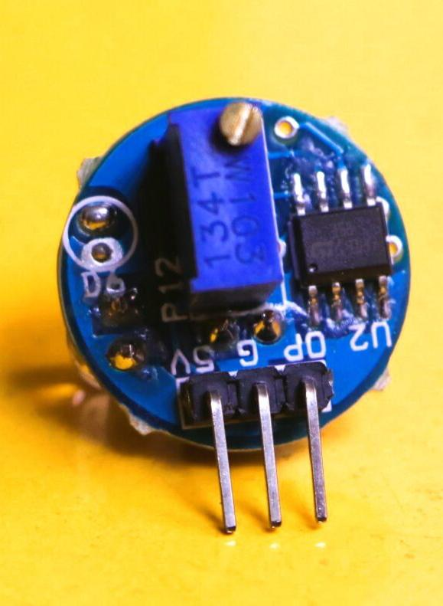

**Fig 4.2 Eye Blink Sensor**

An eye blink sensor, also known as an eye blink detection module, is a device used to detect the blinking of a person's eyes. It is often utilized in applications such as eye-tracking systems, fatigue detection, and human-computer interaction. The sensor typically consists of an infrared (IR) emitter and receiver pair.

**Infrared Emitter:**

The IR emitter emits infrared light towards the eye. This light is not

visible to the human eye but can be detected by the IR receiver.

**IR Receiver:**

The IR receiver receives the reflected infrared light that bounces off

the eye's surface. When the eye is open, the receiver detects the

reflected light, and when the eye blinks, the receiver's signal is

interrupted.

**Signal Processing:**

The sensor's circuitry processes the received signal to determine the

presence or absence of an eye blink. This processing involves

analyzing the changes in the intensity or duration of the received

infrared signal.

**Output:**

The sensor provides an output signal indicating the eye blink status,

typically in the form of a digital signal. For example, it may provide a

logic HIGH or logic LOW output depending on whether an eye blink

is detected or not.

Regarding pin specifications, the exact details can vary depending on the specific eye blink sensor module you are using. However, most eye blink sensors typically have the following pins:

**VCC**: This pin is used to provide the power supply voltage to the sensor module, usually around 3.3V or 5V.

**GND:** This pin is connected to the ground or common reference of the power supply.

**Output:** This pin provides the output signal indicating the eye blink status. It may be a digital output pin that goes HIGH or LOW depending on the detection result.

**Other pins:** Depending on the specific sensor module, there might be additional pins for configuring or calibrating the sensor's behavior, such as sensitivity adjustment or calibration input.

##### 4.1.3 BUZZER:

##### 

##### Fig 4.3 Buzzer

A buzzer is an electronic device that produces sound or an audible alarm. It is commonly used in various applications, including alarms, timers, and notification systems. Buzzer modules usually have two wires, a positive (VCC) wire and a negative (GND) wire.

##### PIN specification:

**Positive Wire (VCC):** The positive wire, also referred to as VCC or power supply, is connected to the positive terminal of the power source (e.g., a battery or power supply). Applying a voltage to this wire activates the buzzer.

**Negative Wire (GND):** The negative wire, also known as GND or ground, is connected to the negative terminal of the power source. It serves as the reference point for the electrical circuit and completes the circuit when connected to the positive wire.

**Operation:** When an electric current flows through the buzzer, it generates sound by causing a diaphragm or a piezoelectric element to vibrate. The buzzing sound is produced as a result of these vibrations.

**Pin Specification:** Buzzer modules may have additional pins for specific functionalities, but the essential pins are as follows:

**a. VCC:** This pin connects to the positive wire (VCC) of the power source, providing the operating voltage to the buzzer. It is often denoted as "+," "VCC," or a similar symbol.

**b. GND:** This pin connects to the negative wire (GND) of the power source, providing the ground reference for the buzzer. It is often denoted as "-", "GND," or a similar symbol.

### 4.1.4 IoT MODULE

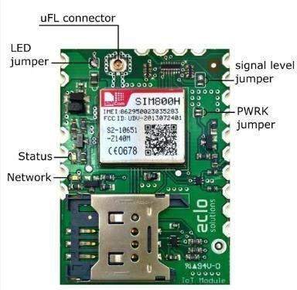

#### Fig 4.4 IoT Module

Internet of Things (IoT) bridges the gap between the physical world and the Internet world, making smarter connections possible between machines and everything. No matter for personal use or for diverse vertical industry applications, IoT addresses its significant values in greater convenience, higher efficiency, improved quality of work/production and better utilization of big data. Digital transformation has become the key to business growth, society growth and economic growth, and IoT will be at the center of digital transformation.

The emergence of more high-performance and cost-effective wireless communication technologies, as well as complicated technological specifications, give businesses more IoT opportunities and options to transform their products into future-ready devices. IoT modules, small computing components embedded in devices to enable wireless communication between the device and the network, are the most critical component in an IoT solution. But among diverse module solutions and various manufacturers available on the market, how to choose the optimal module product will be the core of a successful IoT deployment.

### 4.1.6 MASSIVE IoT MODULES

Fibocom’s massive IoT solutions are modules that features ultra-low power consumption, mainly includes LTE-Cat 1, and LPWA solutions LTE Cat-M and Narrowband IoT (NB-IoT) solutions. These series of modules have excellent cost performance and are ideal for large-scale IoT deployment that requires medium-low rate data and long battery life. NB- IoT guarantees an ultra-low power consumption and extended battery life; LTE Cat M can support voice services while maintaining low power consumption. And LTE Cat 1 is able to support voice and simple display service, and plays a greater role in mobile scenarios like smart logistics and smart law enforcement.

### 4.1.7 SMART MODULES

More interactive IoT applications will demand a larger amount of data processing. Smart modules, which support certain level of computing capability, comes to play an active role in enabling multi-media playing on devices. These modules are ideal solutions especially for applications that require high-definition displays such like smart POS systems, shared rider systems and etc.

### 4.1.8 AUTOMOTIVE-GRADE MODULES

Automotive-grade modules are designed for C-V2X scenarios and to enable autonomous driving. They are widely used in automotive pre-factory installation and aftermarkets applications such like T-Box and ADAS applications. These modules are subject to higher industry standards especially for reliability and security. They also come with more automotive-related features.

An IoT ecosystem consists of web-enabled smart devices that use embedded systems, such as processors, sensors and communication hardware, to collect, send and act on data they acquire from their environments. IoT devices share the sensor data they collect by connecting to an IoT gateway or other edge device where data is either sent to the cloud to be analyzed or analyzed locally. Sometimes, these devices communicate with other related devices and act on the information they get from one another. The devices do most of the work without human intervention, although people can interact with the devices -- for instance, to set them up, give them instructions or access the data.

**4.2.1 ARDUINO UNO**

The Arduino Uno can be powered via the USB connection or with an external power supply. The power source is selected automatically.

External (non-USB) power can come either from an AC-to-DC adapter (wall-wart) or battery. The adapter can be connected by plugging a 2.1mm center positive plug into the board's power jack. Leads from a battery can be inserted in the Gnd and Vin pin headers of the POWER connector. The board can operate on an external supply of 6 to 20 volts. If supplied with less than 7V, however, the 5V pin may supply less than five volts.

The Arduino Uno has a number of facilities for communicating with a computer, another Arduino, or other microcontrollers. The ATmega328 provides UART TTL (5V) serial communication, which is available on digital pins 0 (RX) and 1 (TX).

The Arduino software includes a serial monitor which allows simple textual data to be sent and from the Arduino board. The RX and TX LEDs on the board will 35 flash when data is being transmitted via the USB-to- serial chip and USB connection to the computer (but not for serial communication on pins 0 and 1.

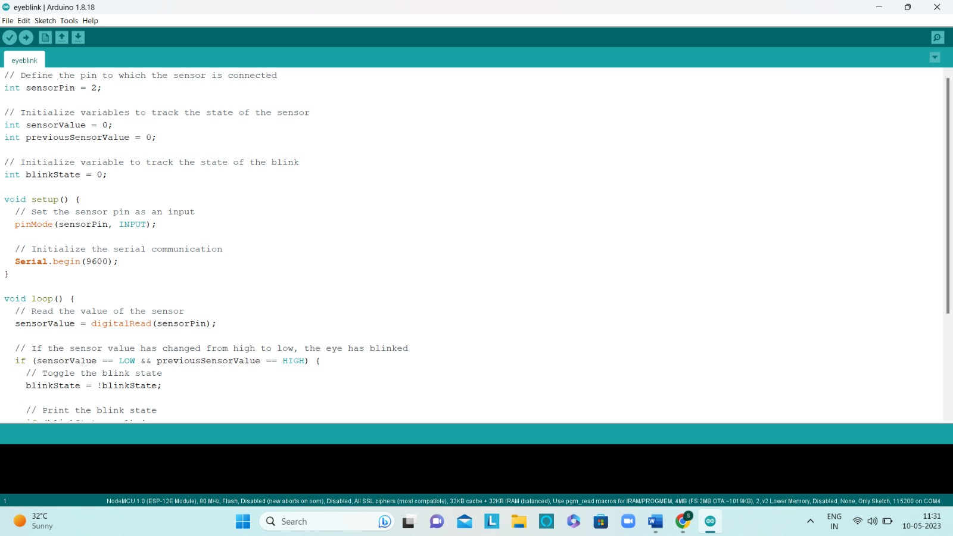

**Fig 4.5 Arduino Program Software**

#### 

#### Fig 4.6 Arduino Program Software

## CHAPTER 5

**RESULT AND DISCUSSION**

**5.1 Implementation result:**

Software program code for running this project. The Arduino uno forms the heart of the system. An eye blink sensor is used for detecting the eye movements or eye closure. When once the eye closed, the voltage level of eye blink sensor goes high and the eye blink sensor waits for 3 seconds then sends the signal to the buzzer. Then the buzzer will trigger when it receives the output from the eye blink sensor.

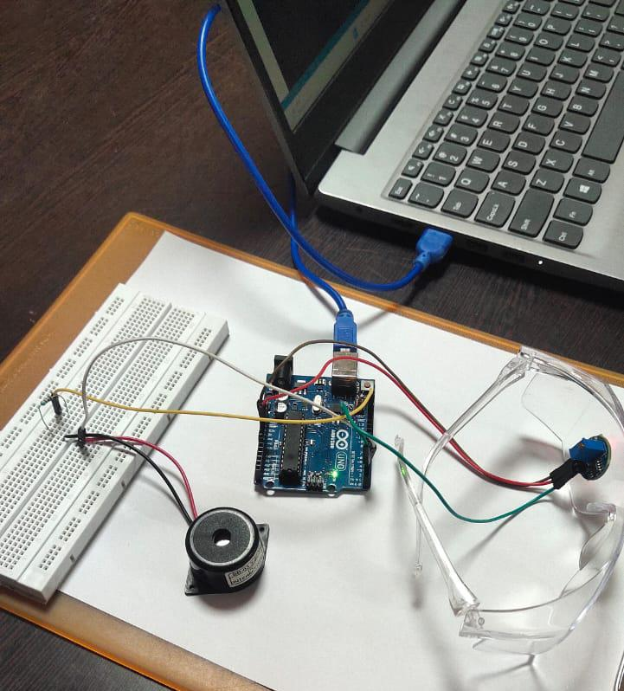

**Fig 5.1 Implemented output**

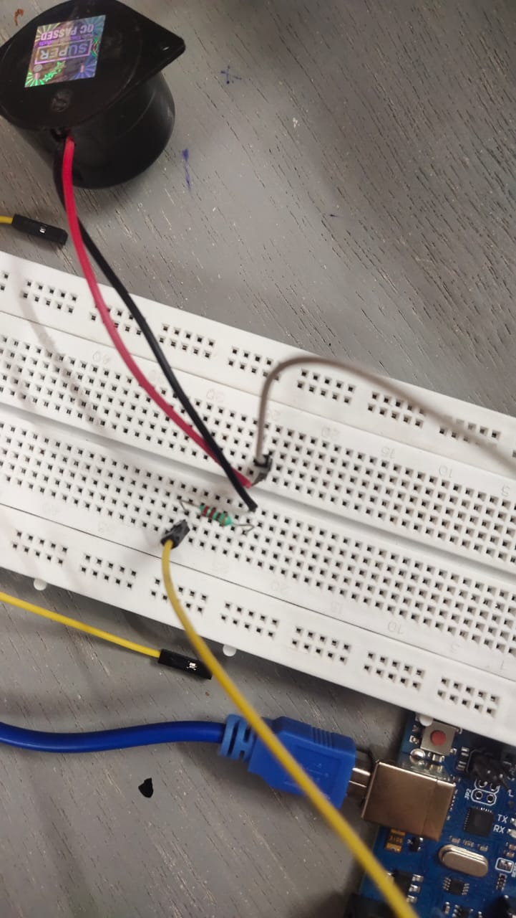

**Fig 5.2 Connection**

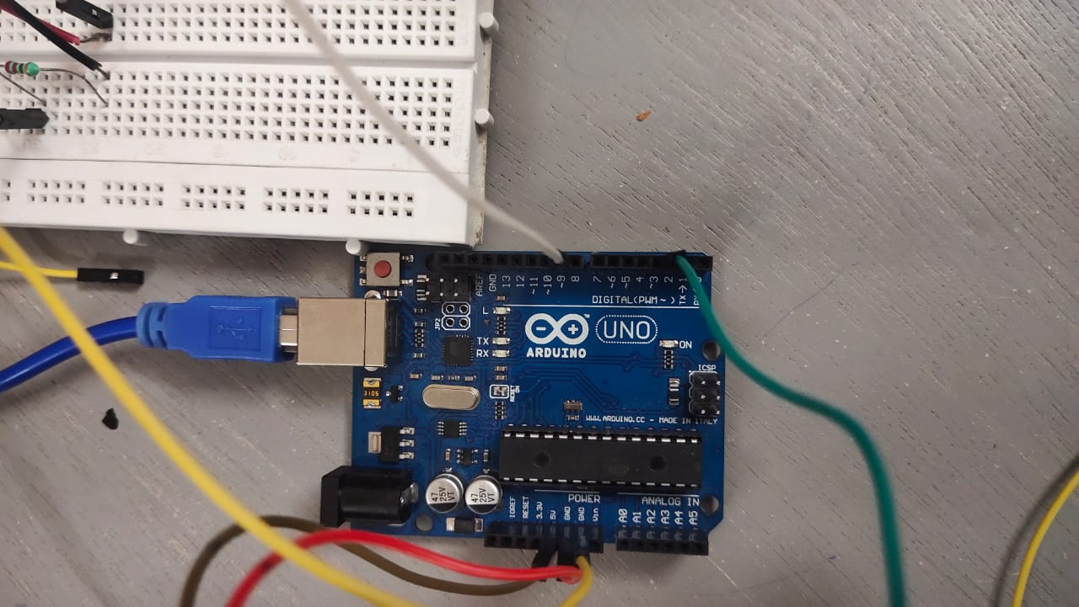

**Fig 5.3 Connection**

Fig 5.2 and fig 5.3 explains the connection made in the system. The positive and negative connection of the buzzer is made in the breadboard. The output from the sensor is connected to the Arduino uno then the signal from Arduino are processed to the buzzer to prompts the driver.

### 

### 5.2 OUTPUT SCREEN SHOT

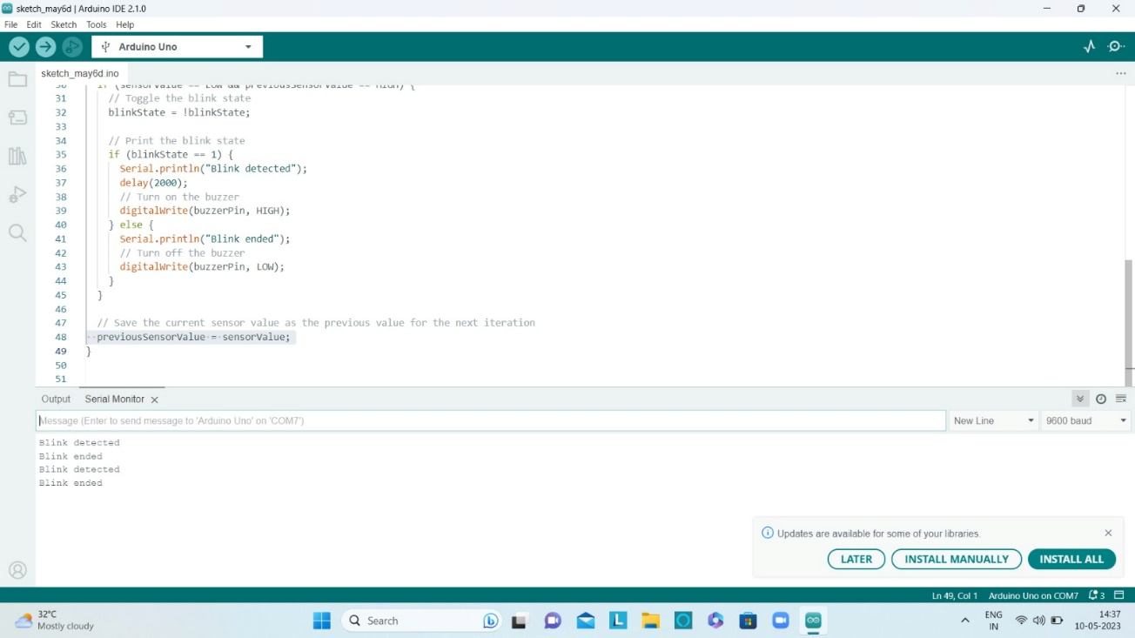

**Fig 5.4 Serial monitor output**

The above figure 5.4 is the serial monitor output of the Arduino ide. Once the sensor detected it shows “Blink detected” in the monitor. After few seconds(3 seconds) as mentioned in the program, buzzer will alert until the driver’s eye opens and “Blink ended” will show in the monitor.

### 

## CHAPTER 6

**CONCLUSION AND FUTURE ENHANCEMENT**

### 6.1 CONCLUSION

The drowsy driver alert system with an eye blink sensor is a valuable technology that contributes to reducing accidents caused by drowsy driving. Its ability to detect early signs of fatigue and provide timely alerts can significantly improve driver safety. However, it should be used in conjunction with responsible driving practices and driver education to maximize its effectiveness. The primary objective of this system is to enhance safety on the roads by detecting drowsiness in drivers. By monitoring the driver's eye blinks, the system can identify patterns indicative of fatigue. It then provides timely alerts to the driver, allowing them to take appropriate action and prevent potential accidents caused by drowsy driving.

Drowsy driver alert systems with eye blink sensors are often designed to be adaptable to individual drivers. They can be calibrated to account for different eye blink patterns and behaviors, ensuring accurate detection of drowsiness. Additionally, these systems can be customized to accommodate various driving conditions, such as different light levels, weather conditions, and vehicle types.

**6.2 FUTURE ENHANCEMENT**

Enable wireless communication capabilities between the components of the system. This would allow the eyeblink sensor and Arduino to transmit data to a central processing unit or a mobile device, providing real-time alerts and analysis.

Expand the system's functionality to monitor sleep quality during rest periods. This could involve integrating a sleep tracking device or leveraging the eyeblink sensor to detect microsleep events, providing drivers with insights into their sleep patterns and overall sleep health.

Implement a more flexible and customizable alert system using the Arduino and the buzzer. Provide options for adjusting the volume, tone, and frequency of the buzzer based on driver preferences and environmental condition.

Integrate the drowsy driver alert system with other in-vehicle systems, such as lane departure warning or adaptive cruise control. In the event of drowsiness detection, the system could automatically activate driver assistance features to help maintain safety until the driver is more alert.

### Utilize advanced algorithms and signal processing techniques on the Arduino Uno or a more powerful microcontroller to analyze the eyeblink data more effectively. This could involve implementing machine learning algorithms to improve the system's ability to distinguish between normal blinks and drowsiness-related blinks.

### 

**6.3 APPLICATIONS**

The application of drowsy driver alert systems aims to reduce the number of accidents caused by drowsiness and fatigue, protect lives, and enhance road safety for both professional drivers and private individuals.

### 

### [1].Automotive Industry: Drowsy driver alert systems are increasingly being incorporated into vehicles as a safety feature. They can be integrated into the vehicle's existing driver assistance systems or as standalone devices to provide real-time alerts to the driver when signs of drowsiness are detected.

### [2].Fleet Management: Fleet operators, such as trucking companies and transportation services, can deploy drowsy driver alert systems to monitor their drivers' alertness. This helps prevent accidents, reduces the risk of driver fatigue-related incidents, and improves overall fleet safety.

### [3].Public Transportation: Drowsy driver alert systems can be installed in buses, trains, and other forms of public transportation to ensure the safety of passengers. Alerting fatigued drivers can reduce the likelihood of accidents and protect the lives of commuters.

**[4].Long-Distance Travel:** For individuals embarking on long drives, particularly during nighttime or extended road trips, a drowsy driver alert system can provide an added layer of safety. It can help prevent accidents caused by driver fatigue and provide timely warnings to take necessary breaks or rest.

**[5].Commercial Vehicles:** Drowsiness is a significant concern for drivers of commercial vehicles, such as delivery trucks or taxis. Implementing drowsy driver alert systems in these vehicles can mitigate the risk of accidents and improve driver safety.

**[6].Ride-Sharing Services:** Companies offering ride-sharing services can prioritize the safety of their passengers by equipping their vehicles with drowsy driver alert systems. This ensures that drivers remain alert during long shifts and minimizes the risk of accidents due to driver fatigue.

**[7].Personal Vehicles:** Individuals can also install drowsy driver alert systems in their personal vehicles to enhance their own safety. This is particularly beneficial for those who frequently undertake long journeys or have irregular sleep patterns.

### REFERENCE :

[1].C. Liu and R. Subramanian, “Factors Related to Fatal Single-Vehicle

Run-Off-Road Crashes,” U.S. Department of Transportation, American

National Highway Traffic Safety Administration, DOT HS 811 232,

Washington, D.C., November, 2009.

[2] R.R. Knipling and J.S. Wang, “Crashes and Fatalities Related to Driver

Drowsiness, Fatigue,” National Highway Traffic Safety Administration,

Washington, D.C., Information Management Consultants Inc., McLean,

VA., 1994.

[3] G. Pan, L. Sun, Z. Wu and S. Lao, “Eyeblink-based Anti-spoofing in

Face Recognition from a Generic Webcamera,” The 11th IEEE

International Conference on Computer Vision (ICCV'07), Rio de

Janeiro, Brazil, October, 2007.

[4] J. Santamaria and K. Chiappa, “The EEG of drowsiness in normal

adults,” Journal of Clinical Neurophysiology, vol. 4, no. 4, pp. 327-382,

1987.

[5] R.P. Nikhil, C. Chien-Yao, L.W. Ko, C.F. Chao, T.P. Jung, S.F. Liang

and C.T. Lin, “EEG-based Subject-and Session-independent Drowsiness

Detection: An Unsupervised Approach,” EURASIP Journal on Advances

in Signal Processing, ISSN: 1110-8657, January 2008.

[6] A. Vuckovic, V. Radivojevic, A.C.N. Chen and D. Popovic, “Automatic

recognition of alertness and drowsiness from EEG by an artificial neural

network,” Medical Engineering & Physics, vol. 24, no. 5, pp. 349, 2002.

[7] B. James, H. Sharabaty and D. Esteve, “Automatic EOG analysis: A first

step toward automatic drowsiness scoring during wake-sleep

transitions,” Somnologie, vol. 12, pp. 227-232, 2008.

[8] J.H. Yang, Z.H. Mao, L. Tijerina, T. Pilutti, J.F. Coughlin and E. Feron,

“Detection of driver fatigue caused by sleep deprivation,” IEEE

Transactions on Systems, Man and Cybernetics, vol. 39, July 2009.

[9] C.C. Liu, S.G. Hosking and M.G. Lenné, “Predicting driver drowsiness

using vehicle measures: Recent insights and future challenges,” Journal

of Safety Research ,vol. 40, no. 4, pp. 239-245, August 2009.

[10] D. Dinges, “PERCLOS: A valid psychophysiological measure of

alertness as assessed by psychomotor vigilance indianapolis,” Federal

### [11] Ueno H., Kanda, M. and Tsukino, M. “Development of Drowsiness Detection System”, IEEE Vehicle Navigation and Information Systems Conference Proceedings,(1994), ppA1-3,15-20.

[12]. J. He, W. Choi, Y. Yang, J. Lu, and X. Wu, Detection of

driver drowsiness using wearable devices : A

feasibility study of the proximity sensor, Appl. Ergon.,

vol. 65, pp. 473–480, 2017.

https://doi.org/10.1016/j.apergo.2017.02.016

[13]. R. P. Balandong, R. F. Ahmad, S. M. Ieee, and M. N.

Mohamad, A Review on EEG-Based Automatic

Sleepiness Detection Systems for driver, IEEE Access,

no. March, 2018.

[14]. J. Gabhane, D. Dixit, P. Mankar, R. Kamble, and S.

Gupta, Drowsiness Detection and Alert System : A

Review, vol. 6, no. Iv, pp. 236–241, 2018.

https://doi.org/10.22214/ijraset.2018.4043

[15]. A. Sahayadhas, K. Sundaraj, and M. Murugappan,

Detecting Driver Drowsiness Based on Sensors: A

Review, pp. 16937–16953, 2012.

[16]. O. Sinha, S. Singh, A. Mitra, S. K. Ghosh, and S. Raha,

Development of a Drowsy Driver Detection System

Based on EEG and IR-based Eye Blink Detection

Analysis. Springer Singapore, 2018.

https://doi.org/10.1007/978-981-10-7901-6_34

[17]. M. Teplan, Fundamentals of EEG measurement,Meas.

Sci. Rev., vol. 2, no. 2, pp. 1–11, 2002.

[18]. V. Saini, Driver Drowsiness Detection System and

Techniques : A Review, Int. J. Infin. Innov. Technol.,

vol. 5, no. 3, pp. 4245–4249, 2014.

[19]. P. S. Electroencephalogram, Portable Drowsiness

Detection through Use of a Prefrontal

Single-Channel Electroencephalogram, pp. 1–19,

2018.

### [20]. C. Chuang, C. Huang, L. Ko, and C. Lin, An EEG-based perceptual function integration network for application to drowsy driving,Knowledge-Based Syst., vol. 80, pp. 143–152, 2015. https://doi.org/10.1016/j.knosys.2015.01.007

### APPENDIX

// Define the pin to which the sensor is connected

int sensorPin = 2;

// Define the pin to which the buzzer is connected

int buzzerPin = 3;

// Initialize variables to track the state of the sensor

int sensorValue = 0;

int previousSensorValue = 0;

// Initialize variable to track the state of the blink

int blinkState = 0;

void setup() {

// Set the sensor pin as an input

pinMode(sensorPin, INPUT);

// Set the buzzer pin as an output

pinMode(buzzerPin, OUTPUT);

// Initialize the serial communication

Serial.begin(9600);

}

void loop() {

// Read the value of the sensor

sensorValue = digitalRead(sensorPin);

// If the sensor value has changed from high to low, the eye has blinked

if (sensorValue == LOW && previousSensorValue == HIGH) {

// Toggle the blink state

blinkState = !blinkState;

// Print the blink state

if (blinkState == 1) {

Serial.println("Blink detected");

delay(2000);

// Turn on the buzzer

digitalWrite(buzzerPin, HIGH);

} else {

Serial.println("Blink ended");

// Turn off the buzzer

digitalWrite(buzzerPin, LOW);

}

}

// Save the current sensor value as the previous value for the next iteration

previousSensorValue = sensorValue;

}

**DROWSINESS DRIVER ANTISLEEP ALARM**

|  |  |  |
| --- | --- | --- |
| **Ms.R.Indumathi M.E.,**  **Electronics and Communication**  **Engineering**  *Vivekanandha college of Engineering for* | | **SATHYABAMA**  **Electronics and Communication**  **Engineering**  *Vivekanandha college of Engineering for*  *women*  *(Affiliated to Anna University)*  Tiruchengode , India  sathya22092002@gmail.com |
| *women*    *(Affiliated to Anna University*  Tiruchengode , India indhuma2228@gmail.com |  |
| **SOBIYA N**  **Electronics and Communication**  **Engineering** |  | **R.SWETHA**  **Electonics and Communication**  **Engineering**  *Vivekanandha college of Engineering for Women*  *(Affiliated to Anna University)*  Tiruchengode, India  Swetharaja357@gmail.com |
| *Vivekanandha college of Engineering for*  *women*  *(Affiliated to Anna University)*  Tiruchengode, India  Sobiyanamperumal31@gmail.com | |

**V.SUBHASHINI**

**Electronics and Communication**

**Engineering**

*Vivekanandha college of Engineering for*

*women*

*(Affiliated to Anna University)*

Tiruchengode, India

Subhashinivj2@gmail.com